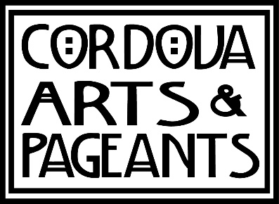 Scholarship Application

This scholarship is open to any Cordova High School senior with a commitment to further their knowledge of the arts at the college level as either major, minor, or elective courses. All arts are considered; visual, performing, literary, media, etc. Amount: $1000

Name:

Address:

Phone: Date:

Name of Local Reference (not a relative):
Instructions: Answer the following in the space provided and submit with your portfolio to the school guidance counselor or Cordova Arts, PO Box 71, Cordova, AK 99574 to be eligible for consideration by the deadline date May 2.

The selection committee is looking for an individual who has demonstrated an interest in and passion for the arts, as well as an express interest in pursuing the arts after high school. Please keep this in mind when writing your responses. Cordova Arts supports in all visual, performing, and literary arts.

Part A: Questions Keep answers to one paragraph, you may use the back or separate sheet.

- Briefly explain your art background and interests.

- Please briefly explain your arts-related plans after graduation.

Part B: Portfolio
To better understand your skills and participation in the arts, please put together a portfolio that is representative of your talents, commitment, and interest in the arts. Cordova Arts will accept any medium necessary to fully convey your talent and work including, but not limited to: video, photographs, audio, DVD, textiles, etc. All materials will be returned

